Case study
Title of Case study | Etno art Pavlović
Keywords (meta tag) | Etno, art, artistic craft
Provided by | REDASP
Language | ENGLISH
Case study

The art workshop ETNO-ART is located in the village of Blaznava, 15 km from municipality of Topola in Serbia.  My name is Danijela Pavlović and I have been the owner of the workshop since 2002.  I live in a healthy environment with my family and I am a mother of two children.  Every day I make and paint souvenirs, useful objects made of wood, leather, glass, ceramics and fabric. | 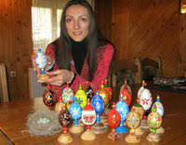
By painting old restored furniture, decorating and painting Etno spaces of various purposes.
I tirelessly try to ensure that all my souvenirs and items are original, studded with unique ideas, based on Šumadija tradition, costume, embroidery and folklore.
Also details from everyday life in Šumadija.
In my small manufacturing workshop, where everything is created with a brush in a way known only to me.
With love, attention, will and desire, I try, and I succeed, to bring a touch of originality and originality into every traditional item of Šumadija and to adapt it to today's.

Guided by the thought that "THE PRIORITY IS TO BE WHAT YOU ARE" was confirmed by the society in which I live and work.

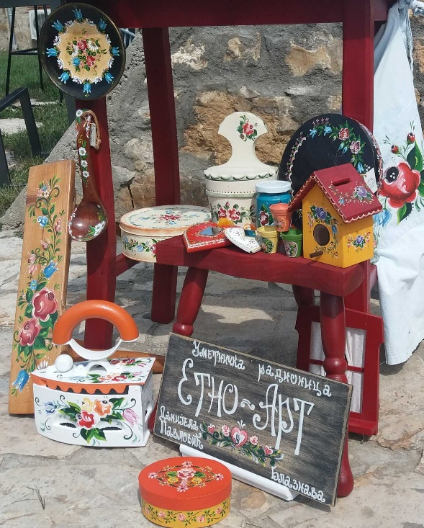 | Thus, in 2012, all my souvenirs and useful items were certified with the "CERTIFICATE OF ANCIENT AND ARTISTIC CRAFTS" of the Ministry of Economy of the Republic of Serbia and registered under the ordinal number 0459 of handicrafts.  My many years of effort and work are marked by many recognitions and awards.  One of those recognitions is the "MASTER LETTER" in 2011, awarded to me by the "Cultural and Historical Center of the Serbian Crown" in charge of preserving the Serbian cultural heritage.
I don't measure my love for my work by money, but by the sighs and smiles of the people who infuse me with faith and hope in what I create every day!
Reference Link (if any) | https://etnoart.rs/  www.facebook.com/u.t.etnoart.daca  Instagram: danijela_etnoart_pavlovic79
Type of material | Case study

